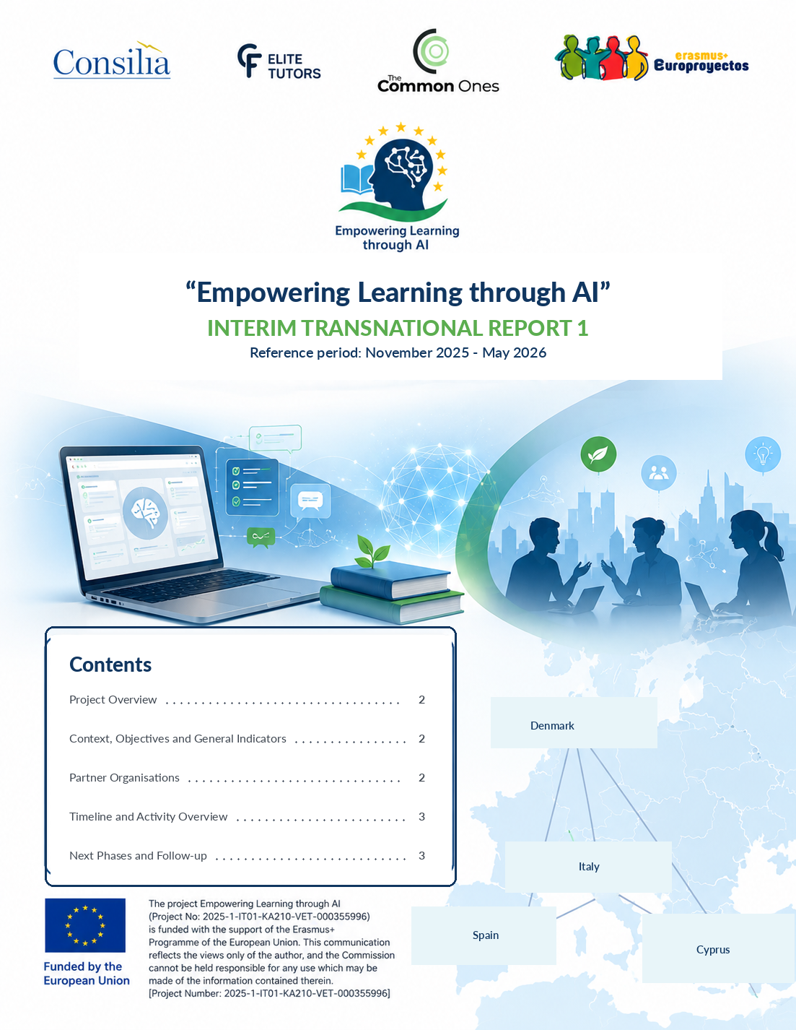

Project Overview
ELAI - Empowering Learning through AI is an Erasmus+ KA210-VET project dedicated to innovation in vocational education and training. Launched in September 2025 and lasting 12 months, it involves four organisations from Italy, Cyprus, Denmark and Spain. The project aims to make artificial intelligence more accessible and useful for trainers, learners and organisations through practical tools for skills mapping, adaptive tutoring, sustainability, social entrepreneurship and international mobility.
This first interim transnational report summarises the activities carried out between November 2025 and May 2026. The document clearly distinguishes the results already achieved, the activities currently being finalised and the next phases of the project.

Project Context and Objectives
Artificial intelligence is rapidly changing the way people learn and develop new skills. In vocational education and training, however, simple, reliable tools that can be easily adapted to different contexts are needed. ELAI was created to bridge this gap by supporting digital innovation with a focus on inclusion, personalisation, training quality and the green and digital transitions.
The main objectives of the project are:
- Integrating AI into vocational education and training: developing tools to identify skills needs, personalise learning pathways and monitor learners' progress.
- Promoting green skills and social entrepreneurship: providing practical resources to analyse the environmental and social impact of initiatives.
- Improving international mobility experiences: preparing AI-supported tools for preparation, monitoring and reporting.
- Assessing training impact: promoting the informed use of data to improve future activities.

General Project Indicators
The project foresees concrete and measurable results. The following indicators provide the reference framework for monitoring overall progress:
- R1 - Skills and adaptive tutoring tools: 1 Methodological Guide, 3 AI-guided checklists and 5 sets of practical templates.
- R2 - Green skills and social entrepreneurship: 1 structured Toolkit, 1 green assessment framework and 1 social impact framework.
- R3 - International mobility: 1 practical handbook, 1 pre-mobility self-assessment tool, 1 real-time monitoring system and 1 post-mobility report template.
- R4 - Impact assessment: 1 AI-enhanced Toolkit for monitoring, data analysis and reporting.
- Participation and dissemination: overall involvement of at least 12 VET trainers in the pilot testing activities; at least 60 students, job seekers and professionals using the materials produced; at least 1,000 recipients reached through dissemination activities; and at least 70% of the trainers involved using the tools produced three months after the end of Activity 4.

Partner Organisations
ELAI brings together four organisations with complementary expertise in vocational education and training, personalised learning, sustainability, social entrepreneurship and international mobility.
Consilia Formazione Srl - Italy
Consilia Formazione is a private vocational training provider accredited by the Lazio Region. It designs and manages upskilling pathways for companies and workers, with activities covering corporate training, consultancy, skills development, sustainability and digital transformation. In the ELAI project, it acts as coordinator: it leads overall management, monitoring, administrative and financial aspects, and Activity 5 dedicated to dissemination and impact assessment.
Private Institute C.F. Elite Tutors Ltd - Cyprus
Elite Tutors works in adult education and vocational training, with particular experience in distance learning, language learning and personalised pathways supported by artificial intelligence. In the project, it leads Activity 2, dedicated to skills mapping and adaptive tutoring, coordinating the development of the Methodological Guide, checklists and practical templates.
The Common Ones - Denmark
The Common Ones is a non-profit organisation that promotes green skills, social entrepreneurship and innovation for the circular economy, and supports start-ups. It develops experiential programmes, workshops, mentoring activities and training resources to turn sustainable ideas into concrete initiatives. In the project, it leads Activity 3 and coordinates the finalisation of the Toolkit for green skills and social impact.
Europroyectos Erasmus Plus - Spain
Europroyectos specialises in Erasmus+ programmes and international mobility. It supports students, VET learners and educational staff in preparing experiences abroad, managing logistics, supporting cultural integration and developing professional and transversal skills. It hosted the kick-off meeting in Córdoba and will lead Activity 4 dedicated to integrating AI into mobility pathways.
Summary Timeline
- November 2025: project launch and transnational kick-off meeting in Córdoba; definition of shared working rules.
- November 2025 - spring 2026: development and pilot testing of Activity 2 with VET trainers from all partner countries.
- Spring - June 2026: research, design and finalisation of Activity 3.
- Next phases: pilot testing of the A3 Toolkit, development of tools for international mobility and impact assessment.

Activity Overview
The project is structured into five interconnected activities. The first ensures overall coordination; the following activities translate ELAI's objectives into tools that can be used by trainers and learners.
A1 - Project Management | Status: ongoing
- Reference period: November 2025 - November 2026.
- Activities carried out: kick-off meeting in Córdoba, Project Management Plan, risk register, KPI framework, common templates and shared digital workspace.
- Relevant indicator: 4 partner organisations coordinated through periodic meetings, reporting and continuous monitoring.
A2 - AI Tools for Skills Mapping and Adaptive Tutoring | Status: completed
- Objective: to help trainers identify skills needs, interpret data and personalise learning pathways during the assessment phase.
- Results produced: 1 Methodological Guide, 3 AI-guided checklists and 5 sets of practical templates.
- Pilot testing: 1 pilot test carried out in all partner countries with 3 VET trainers per organisation, for a total of 12 trainers involved.
- Use of feedback: the materials were revised to improve their clarity, practicality and transferability to everyday training activities.
A3 - Toolkit for Green Skills and Social Entrepreneurship | Status: being finalised
- Objective: to produce an operational Toolkit for designing training sessions on sustainability and social impact.
- Preparatory research: partners analysed practices, needs and challenges in their national contexts to guide the design of the Toolkit.
- Toolkit structure: 2 complementary tracks - Green Lens for environmental impact and Impact Lens for social impact - organised according to an 8-block sprint methodology with worksheets, Canvas tools and AI prompts for training in green and entrepreneurial topics.
- Next step: pilot testing of the Toolkit with at least 12 VET trainers.

Next Phases and Follow-up
After the finalisation of Activity 3, the partnership will continue by producing tools dedicated to international mobility, developing tools for training assessment, and supporting the overall evaluation and promotion of the project.
A4 - AI-supported International Mobility | Status: next phase
- Objective: to improve the preparation, monitoring and valorisation of international mobility experiences.
- Expected results: 1 practical handbook, 1 pre-mobility self-assessment tool, 1 structured real-time monitoring system and 1 post-mobility report template.
- Responsible partner: Europroyectos Erasmus Plus.
A5 - Dissemination of Results and Impact Assessment | Status: final project phase
- Objective: to disseminate the results, monitor training effectiveness and support the future use of the tools developed.
- Expected result: 1 training impact assessment Toolkit, with tools for monitoring, data analysis and AI-generated reporting.
- Relevant indicators: at least 1,000 recipients reached through dissemination activities; at least 70% of the trainers and educators involved oriented towards applying data-driven assessment methods after the completion of Activity 4.
- Responsible partner: Consilia Formazione Srl.

